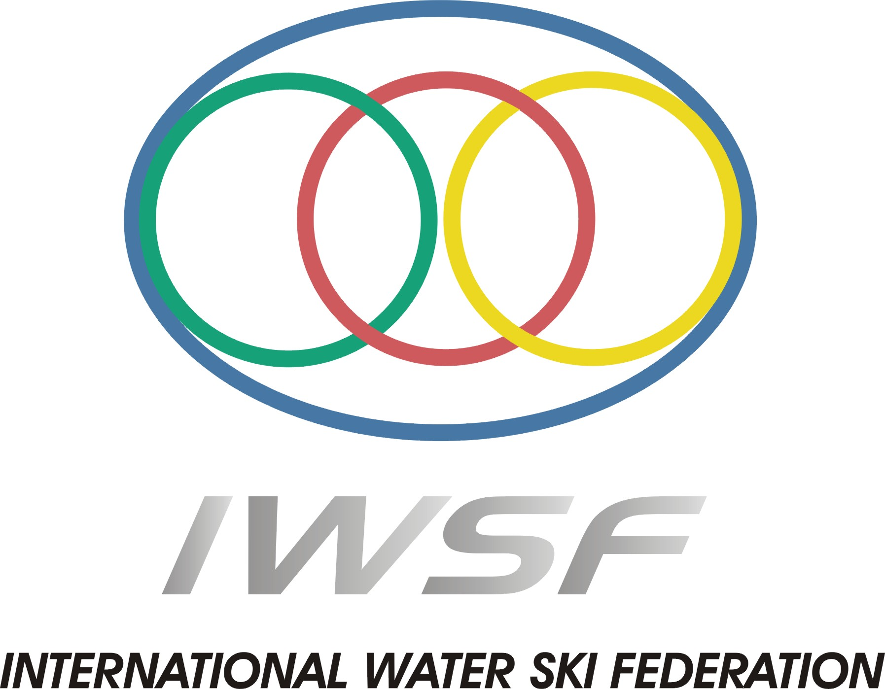

2010 NAMIBIAN OPEN NATIONAL CHAMPIONSHIPS
&
2010 ALL AFRICAN CHAMPIONSHIPS

BULLETIN 1

Namibia and the Namibian Water Ski Association welcomes you to...

NAMIBIAN OPEN WATERSKI CHAMPIONSHIPS AND ALL AFRICAN WATERSKI CHAMPIONSHIPS 2010

INTRODUCTION

VON BACH DAM NAMIBIA

1-5 APRIL 2010

This is the first information bulletin for the 2010 Namibian open Championships and All African Water Ski Championships. The next bulletin will follow shortly with more information. For any additional information, feel free to mail us on martin.schmidt@mtcmobile.com.na or Monique Kamfer at
mkamfer@awutow.com.na
LOCATION OF THE SITE
Von Bach dam is 70km north of Windhoek on the B1
The site is a lake that over the years has been used for many standings list homologated competitions.
The competition area is a well-sheltered area with minimum backwash.
When coming by airplane, use the Hosea Kutako international airport. Once you have picked up your rented car at the International airport, follow the exact directions to the ski site below.

DIRECTIONS

Once you leave the airport, take the main road Sam Nujoma Drive to Windhoek At the intersection of Sam Nujoma and Robert Mugabe turn right. Follow the road till you get to the T-junction where you will turn right. Follow the road past 3 robots and a traffic circle continue round the traffic circle through the next intersection. At the next robot after the intersection and the sign board that says Okahanja and B1 turn right on the B1. Continue for 70km till you get the sign board, just before Okahanja that says S Von Bach Dam. Follow the signs to the dam.

TRANSFERS
Transport from Airport to Von Bach dam – just mail me your flight details latest 8 March 2010 and this can be arranged at a cost of
R300 per person.
Only two trips per day one in morning one in afternoon.
IF more than 4 persons on one-trip transfer rates will be NS200 per person

Airfares
For Special air fares please contact Heike Schultz at Tel: + 264 61 260 366
Or Cell: + 264 85 128 2544 or
e-mail Heike.Schultz@rennies.hrgworldwide.com

ENTRY
Entry Fees for Namibia Open Champs and All African Championships per competition:

- Official Practice (4 passes) : R 100
- Slalom: : R 300
- Slalom and Tricks : R 350
- Slalom, Trick and Jump : R 450

PAYMENT
- All on site fees i.e. Training Fees, entry fees, meals, drinks etc. can only be paid in cash.

CATERING ARRANGEMENTS

Please advise if you require breakfast, lunch and dinner on site:

Cost for a meal package is R750.00 (Thurs dinner to Sunday lunch including the Formal dinner. Continental Breakfast, Light Lunch of burgers/hot dogs and braai and salads for dinner just to give you an idea of what is included…..
You should know the drill – Henk and Maryke will once again be our food hosts!

No. of sets of meals

Please confirm by 22 March to allow for catering

Evening formal dinner function only – Saturday ….

Buffet dinner Adults @ R140.00 per person
Buffet dinner Under 12 @ R70.00 per person

OTHER MEALS: If you are not purchasing the package, please indicate the number of meals per day below.

Thursday dinner: R 100.00 Numbers………..
Friday Breakfast: R 50.00 Numbers ……….
Friday Lunch: R 50.00 Numbers………...
Friday Dinner: R 100.00 Numbers ………..
Saturday Breakfast: R 50.00 Numbers ………..
Saturday Lunch: R 50.00 Numbers ………..
Saturday Dinner: R 100.00 Numbers ………..
Sunday Breakfast: R 50.00 Numbers ………..
Sunday Lunch: R 50.00 Numbers ………..
Sunday Dinner: R 140.00 Numbers ………..
Monday Breakfast: R 50.00 Numbers ………..
Monday Lunch: R 50.00 Numbers ………..

Please confirm by 22 March 2010 to allow for catering

RESERVATIONS FOR TRAINING

- It is not possible to train on site before the tournament, However this is at the tournament organisers discretion and final decision, but there will however be official practise on site on 1st April 2010

ALTERNATE TRAINING SKI SITES

There is a normal list slalom course at the Von Bach Water Ski Club where you can train before the tournament:
Training will be available at NS 300 per set +- 15 to 20min

Please contact me if you want to train and we will then allocate time to each skier.

TRAINING PRIOR TO THE CHAMPIONSHIPS

The Namibian Water Ski Association is looking to bring in Loïc Ricaud from France, from the 14 March till the all Africa champs. Loïc was the EAME under 21 champion recently and is willing to come and give us training.
We are hoping to keep the costs real low provided we find a sponsor for it. Please indicate weather you would be interested so that we know whether or not it will be viable at all.
Costs subject to change, but we are thinking in the order of R150 per 15min

ACCOMMODATION

Please let me know whether you need accommodation so that I can arrange it

For any other accommodation options, please contact Martin so that he can arrange places or tel numbers for you.

Meals before Thursday can be arranged for the skiers coming to train before the competition

Park Entrance fees NS 30 per person per day

COMPETITION

The official tow-boats for both events will be the a Ski Nautique196 with version Zero off
Both tournaments will be standing list.

FUNCTIONS
Friday evening will be the official Opening ceremony of the All African Championships. All Teams to bring tracksuits

Sunday Evening will be the Gala Dinner Buffet and prize giving and our theme will be Hawaiian Beach party, so bring something funky to wear. Prizes for the best-dressed man & woman

Details will follow in the next bulletin

INTENTION TO ENTER –

NAMIBIAN CHAMPIONSHIPS AND

ALL AFRICAN CHAMPIONSHIPS

See entry form at the bottom of this bulletin
Please complete the intention to enter form and email it to martin.schmidt@mtcmobile.com.na or fax it to + 264 61 244 218.
The closing date for entries is 22 March 2010 and a penalty of R150 will apply for late entries

FLAGS & ANTHEMS

Each team must bring their own countries flag.
Each team to bring an additional flag of their country, for each medal position anticipated, for the medal presentation. Size approximately 90 x 150cm
All teams are also requested to bring a CD with their national anthem

OFFICIALS still to be finalised

Chief Judge Louis Polome (All African Champs) RSA

Homologator Brett Nieuwstad ?? RSA
Assnt homologator Gary/Grant Nam

Calculator Sally Gaze RSA

Judges
Cathy Polome RSA
Brett Nieuwstad RSA
Sue Huer ?? RSA
Samantha Martin ?? RSA

Drivers Martin Schmidt Nam
Bernd Kebel Nam
Eckard Waldschmidt Nam
Wiets Coetzee Nam

PROVISIONAL PROGRAM
This will follow Bulletin 2

GENERAL INFORMATION

Unfortunately we do not have credit/debit card facilities all payments in cash and pre arranged with organisers

This is a malaria-free area so no malaria tablets are needed, but please bring peaceful sleep spray or purchase it on your way to the dam; there are a few mozzis around.

Please don’t forget your torch, as we do not have lights all over the camp

We look forward to welcoming you to Namibia, land of open spaces

MARTIN SCHMIDT
EVENT CO-ORDINATOR
NAMIBIA WATER SKI ASSOCIATION

ALL AFRICAN CHAMPIONSHIPS RULES

01: Competition

The African Championships will be held bi-annually. The competition is restricted to skiers residing in Africa. Where the country has a federation, the skiers must have permission to participate as well as prove of membership of their federation. The following rules are departures from the IWSF Rule Book.

02: Categories

The 4 categories for the tournament are:
Dolphin boys/girls: Under 14 years of age
Junior boys/girls: Under 17 years of age
Open men/women: Open to any age
Senior men/women: 35 years of age and over

The contestant’s age is determined as at midnight of 31 DECEMBER prior to the tournament

03: Qualifications

The qualifications for the African Championships are as follows:
Slalom: Clear slalom course at minimum speed (refer to 18.06)
Ramp: Land three consecutive jumps
Tricks: None

04: Teams

Each country will be entitled to send a team of 16 skiers with no more than 6 skiers in any one division. There is no restriction as far as the number of each sex.

In addition the host country may enter a full team whether the skiers qualify or not. The host country is also permitted to enter a promotional team of 4 skiers.

05: Competition Format

Two rounds (a first and a second) of each of the three disciplines will be run.

06: Starting Speeds and Ramp Heights

The minimum starting speeds for slalom and the maximum speeds for ramp and the ramp height are tabled below.

DIVISION |  | MEN/BOYS | WOMEN/GIRLS
Dolphins | Slalom Starting Speed | 40 km/h | 37 km/h
 | Slalom Shortening Speed | 55 km/h | 55 km/h
 | Ramp Speed | 48 km/h | 45 km/h
 | Ramp Height | 1.50 m | 1.50 m
Juniors | Slalom Starting Speed | 43 km/h | 40 km/h
 | Slalom Shortening Speed | 58 km/h | 55 km/h
 | Ramp Speed | 51 km/h | 51 km/h
 | Ramp Height | 1.50/1.65 m | 1.50 m
Open | Slalom Starting Speed | 46 km/h | 43 km/h
 | Slalom Shortening Speed | 58 km/h | 55 km/h
 | Ramp Speed | 57 km/h | 54 km/h
 | Ramp Height | 1.50/1.65/1.80 m | 1.50/1.65 m
Senior | Slalom Starting Speed | 43 km/h | 40 km/k
 | Slalom Shortening Speed | 55 km/h | 55 km/h
 | Ramp Speed | 57 km/h | 51 km/h
 | Ramp Height | 1.50/1.65 m | 1.50 m

07: Classification/Team Points

- There will be a classification for each event (slalom, tricks and ramp) as well as an overall classification for each of the categories. The event classification will be done on the highest performance of either the first or the second round. The overall points in each event for each of the categories will be calculated as follows from the EAME standings:

Overall point for event = (Skiers best performance X 1000)/EAME standing for category

- To determine the All-Africa champion there will be a classification for each event as well as an overall classification for the competition (i.e.: all the categories combined) based on the following:

Overall point for event = (Skiers best performance X 1000)/Open EAME standing

These points are separated from the rest of the team and overall points.

- For the Team Points the best four overall scores in any of the categories in each of the events (in either the first or the second round) will be used for the Team Score in that event. The total score in the three events will give the Team Overall Score.

08: Records

African Records will be recognized for all events in all four divisions. Only performances obtained under Standing List or Normal Homologation will be considered for ratification.

For African Records to be ratified under Normal List homologated tournaments, it is required that a video is available of the trick event and that the slalom and jump course is in Standing List Homologation.

African skiers can establish African Records at any sanctioned competition.

09: Medals

NWSA will supply the medals for the Overall African Champions as well as the Team medals. The tournament organizer will supply all the medals for each event in each of the categories.

10: Entry Fees

Slalom R 300.00
Slalom and Tricks R 350.00
Slalom, Tricks and Jump R 450.00

INTENTION TO ENTER – ALL AFRICAN CHAMPIONSHIPS 2010 Namibia

The ………………………………….. Federation intends to participate in the 2010 ALL AFRICAN CHAMPIONSHIPS.

The team will consist of: Number of people:

Men ………………..
Women ………………..
Staff ………………..
Individual Entries ………………..

Name of Team Captain: …………………………………….

Name of the person in charge of the Team: ……………………….…..

PERSON TO CONTACT:

Name: ……………………………………Function:…………………..

Address: ………………………………………………….
.
…………………………………………………………………………..

Tel No:……………………………… Mobile No……………………...

Fax No:…………………………….. Email:…………………………..

PLEASE SEND THIS FORM BEFORE 8 MARCH 2010

NAMIBIAN WATERSKI ASSOCIATION
Martin Schmidt
TEL. +264 81 127 2022
FAX: +264 61 244 910
e-mail martin.Schmidt@mtcmobile.com.na

or

Monique Kamfer
NWSA Secretary
TEL. +264 81 124 7600
FAX: +264 61 227 445
e-mail: mkamfer@awutow.com.na

Namibia and the Namibian Water Ski Association welcomes you to...

NAMIBIAN OPEN WATERSKI CHAMPIONSHIPS AND ALL AFRICAN WATERSKI CHAMPIONSHIPS 2010

1 – 8 April 2010

2010 Entry form

Surname/Name
Address |  |  |  |  |  |  |  |  |  |  |  | code
Date of birth |  |  |  |  |  |  |  |  |  | ID No.
E-mail address
Phone No. |  |  |  | Home: |  |  |  |  |  | Cell:
Male |  | Female
Division
Tournament |  |  |  | Slalom |  |  |  | Tricks |  | Ramp | Ramp height
Namibian National Championships
All African Championships

TC rules and conditions apply to all entries.

----------------------- -------------------------
Signature Date

Fax entry to: Martin + 264 61 24 4218

Entry Fees per competition are as follows:
Official Practice (4 passes) R 100.00
Slalom R 300.00
Slalom and Tricks R 350.00
Slalom, Tricks and Jump R 450.00

